Maine Library of Geographic Information Board Meeting

01/17/2023

10:00 AM

|  |  |  |  |
| --- | --- | --- | --- |
| Seat # | Attending | Present/Online | Notes |
| 1 | Sharon Horne | X |  |
| 2 | Brian Guerrette | X |  |
| 4 | Nate Kane | X |  |
| 5 | Vinton Valentine | A |  |
| 6 | Gregory Copeland | X |  |
| 7 | *Vacant, Statewide Association of Municipalities* |  |  |
| 8 | Leticia vanVuuren | X |  |
| 9 | Walter Anderson | X |  |
| 10 | *Vacant, Reals Estate and Development* |  |  |
| 11 | Sarah Haggerty | X |  |
| 12 | *Vacant, Public Utilities* |  |  |
| 13 | Aaron Weston | X |  |
| 14 | Patrick Cunningham | X |  |
| 15 | Mal Carey | X |  |
| 16 | Maria Jacques | X |  |
| Staff: | |  |  |
| Jay Clark, Executive Director | |  |  |
| Guests: | |  |  |
| Yeitz, Laura | |  | Laura.Yeitz@maine.gov |
| Weatherbee, Sarah | |  | Sarah.Weatherbee@tetratech.com |
| Emily Dwinnells | |  | edwinnells@gmail.com |
| Terry Shehata | |  | terry.shehata@mainespacecorp.org |
| Tracey Scopel | |  | Tracy.Scopel@maine.gov |
|  | |  |  |

10:00 Roll Call –Jay

Roll sheet is above 11 members present, 1 absent.

10:05 Election of Board Chair

After indicating that she would accept a second term, Leticia vanVuuren was nominated by Maria Jacques and the nomination was seconded by Greg Copeland. All voted yes except for Vinton Valentine who was absent.

Y= 11, N=0, A=0

10:12 Minutes from December Meeting

Minutes were approved. Yes = 11, No =0

10:15 Executive Director’s Report

Jay presented the Executive Director’s report for the month.

1. USGS LiDAR contracting has begun.

2. We have a lot of money to spend!

3. PVL RFP is in Purchasing review.

4. Annual Report is submitted in hard copy.

User statistics and other metrics current to December 1, 2023, are in the report.

5. 3 board seats still vacant.

6. New employee positions still unavailable. Sharon suggested that we not wait to develop job descriptions but work those in parallel to the HR process.

A review of the scope priorities determined by the Board at the November meeting was provided as a refresher from our last planning session.

10:20 Walter Anderson gave the Board a proposal on establishing a “geo-heritage” site in the Greater Katahdin Region. The thrust of the idea is to tie geological awareness to recreational activities such as hiking, camping, and exploration in the region. Walter is a co-author of this concept paper with Robert Marvinney and Chunzeng Wang. The presentation explained the greater global geology and how the Appalachian region was tied to Western EU geologically. Examples were provided for structure of rocks and how the proposed Geo-heritage site might be laid our and signage provided. The proposal also includes educational opportunities for organizations in the area.

Walter has numerous examples of organization that have provided endorsements of the concept.

It was suggested that Walter work with Jay to come up with a 1-page document that explains the concept of a “geoHeritage” site and come back to the board for clarification on possible actions. The Board took no action.

11:12 AM Break

11:21 AM Maine Space Complex Space Data & Advanced Analytics Center Collaboration

Emily Dwinnells joined the meeting

Terry Shehata joined the meeting  
The presentation on the Space Center was suggested by Vinton Valentine for the Board

Terry wears two hats, but one of the hats is really focused on today.  
He is the executive director of the Maine Space Grant consortium.  
That's part of the NASA network that focuses on education and research infrastructure.  
He is speaking to the Board today in his capacity as the Interim Executive Director of the Main Space Corporation, and this organization is a quasi- independent state entity taking the lead per the enabling legislation to basically shepherd the state into the new space economy.  
This has been a work in progress for the past four years.  
It has been shepherded by the Space Grant consortium, in of February of last year's UH 2022, a strategic plan was submitted to the governor and to the legislature to develop the space complex.  
Part of that recommendation, is to create this the quasi-state entity which is a corporation.  
The bill to establish the corporation was signed into law by the governor in April of 2022.  
The oversight for the corporation is a 17 member board.  
Six of them are actually officio that represent, the University of Maine system, the Community College system, MTI and 3 others.  
Eleven members that are nominated by the governor and confirmed by the Senate this past June, the members were confirmed by the Senate and the organization had its first organizational meeting.  
They are preparing implementation plans for three business units of the corporation, which include the Space Data and Advanced Analytics Center,  
the Space Research and Development Innovation Hub, and the Launch Sites and Services both for vertical and horizontal launches. Vertical someplace off Washington County with approval of various communities there.  
And the horizontal launches would be taken advantage or leveraging the long run ways at Brunswick as well as former strategic bases.  
The Innovation Hub will be primarily located at Brunswick Landing with spokes at other places.  
Space Data Analytics is Headquartered at Brunswick, but because of its virtual nature will have spokes throughout the state, including University of Maine system, perhaps, and of other locations.  
  
They have been working with the UM Spatial Institute for the past couple of years basically to develop a framework for the for the data analytics center.  
UM as a concept for all the business units of the corporation.  
The idea here is to leverage existing assets that occur that are in the state, whether it's data analytics or innovation not to reinvent the wheel, but basically to leverage the expertise and the capacity and build upon those capacities wherever that they are.  
As a state independent agency, that's basically the focus of the corporation.

For the past couple of years they’ve worked with Vinton and Elaine at the Geospatial Institute to really have a better understanding of the geospatial and data analytics expertise that we have in the state.  
One of the things that they had decided to do collectively is really to do with some of the work that Emily has been doing with the Climate Change Council, which is to identify a series of business use cases that could be the seed for the Data Analytics Center.  
They began to focus on blue carbon and now there is a proposal that's being developed by the University of Maine USM Orono Institute to develop the capacity in the state for addressing blue carbon, which is a priority of the Climate Change Council.  
The important information to convey is that the purpose of the Space Data Analytic Center, which is a function that a corporation is required to look into to ensure that all parties, all stakeholders in the state, have access to the appropriate space, satellite based data or data.  
That includes data from drones and aerial to support community development andsupport research to support education.  
So the intent of that center is really not to we keep what already exists, but to leverage the resources and to provide the necessary capacity to build upon that.  
So part of the implementation plan that we're looking at right now is is really to is to set the stage by which we would accomplish that requirement in the legislation.  
They have been working with uh Vinton and Elaine to have a better understanding of what assets the State has. We recognize that the GeoLibrary community is really critical at statewide level of providing access to some of the data that exist.

“We want to convey to you all that the intent is really not to reinvent the wheel, but to is to have a better understanding of what your needs are”.

So with that, they can incorporate it into their overall plan.  
One of the things that they are looking at right now, and this is a perhaps part of the conversation that really led to the meeting today, is that one of the things that we're focusing on right now is the development of a dashboard that will contain all the data that that people are looking for in the right format, whether it's existing data or data that needs to be collected.

The corporation will be involved and in building a special satellite primarily, dedicated to the state's needs.  
  
“We would like to work together to realize the potential of the state in terms of how it uses and has access to space related data that could be used for economic development, community development research and as well as education.”  
  
Tony turned the discussion over to Emily at 11:36.

Emily discussed the data analytics portion of the overall space economy.  
“Today the economy is roughly 400 billion dollars worldwide, and the products and services that come from the satellites are roughly 25% of that market.  
25 to 35% depending on the year, but essentially it's a pretty big component of the overall space industry.  
And if you look at where the space industry is in Maine, we do have participants and businesses that are really involved in the upstream portion of the value chain, which is around manufacturing, innovation, design, spacecraft development, rocket development.  
But the downstream portion, which is getting the data from satellites to satellites of collected downlinking it using it productizing it and creating a service around it.  
We don't really have that.  
That's sort of an empty space right now that we hope in the future will begin to be filled in.  
One of the things we're looking toward is not only to be able to acquire data sets, have a sort of robust base data library, but also work, as Terry said, with other organizations in the state of Maine that are data focused to collect datasets and collaborate or partner on projects and things of that nature.  
He also mentioned there's an innovation and R&D hub.  
We intend to help support the startup of space data and analytic businesses.  
So that's another piece of it.  
In the same way that we would supportthe development of a rocket manufacturer or another part of the space economy, we also have an eye towards supporting the development of new space data companies.

I think the final point is part of the value add of the space data analytics is to help Maine businesses and organizations kind of move towards the adoption and use of space data. Space data (and it could be data in general) will help enhance management decision making.

We are interested in finding new innovative ways to use the data, and, partnering with companies and organizations across the state to develop their data literacy.  
We can drive demand for it and have a greater value and use statewide.”

Terry – “The bottom line here is that the corporation would be looking to build a partnership with your organization, because I think we have some common needs and the critical part is that what we're looking for in terms of the corporations, how best to build the capacity that needs to be built in this state, whether it's equipment or personnel or whatever is necessary to enable Maine to be in the forefront of accessing space data and not only provide it for the communities that would be targeted for community development or for research.  
We will also provide the data that would enable entrepreneurs to develop applications in existing industries, but also to push new frontiers in, in using satellite data for consumer products as well.

Questions:

The GeoLibrary provides services without fee structure attached to it hand off data without any charges for the public benefit.  
How will your economic model fit in with that over time?

Terry Shehata   
“This is something that we're looking at right now.  
Whatever we do needs to be self-sustainable, but there are certainly uses of the data that would be provided without any charge for the public benefit.

When it comes to the commercial sector and companies or entrepreneurs or startups that want to have access to data to develop applications, then the financial model for generating fees would be applicable to that.  
But there will be no disruption to the existing community that have that have historically given access to that data without any charging any fees.  
Part of the lessons learned and what we're trying to do at the corporation is really to understand how other partners work so we do not disrupt the current approach or the current models that the partners utilizing.  
Umm, so I hope that answers your question.”

Question - When you were talking and you were describing your organization, are you a state agency or a pseudo-state agency or are you a private corporation?

Terry Shehata – “The corporation is a quasi-independent state agency and it's a model very similar to the Main Technology Institute or the main International Trade Center.  
We're not a nonprofit yet. This is something that we're looking into.

That's in the enabling legislation.”

Terry requested that we schedule an in-person meeting to discuss this in more depth.

Clark, Jay “We have better understanding of your structure and your plans, Documents would be useful, and you can write to me, and I'll distribute to the board.”

Terry suggested that we could form a smaller working group to focus on information exchange and partnership details.

Jay acknowledged that this would be desirable and that the Board would discuss working groups in the afternoon session.

12:00 Lunch

A one-hour lunch break was taken.

Several Board members met and toured Maria’s new 911 training offices. These facilities may be used for Board meetings in the future.

1:00 Financial

The GeoLibrary just received in addition to the $500,000 from the General Fund, a $125,000 commitment from DOT to go toward remote sensed data collection. The invoicing for the DOT funds must done by the Library. Jay will follow up on the invoicing.

There was discussion on the recent funding by the Legislature for both the GeoLibrary and MeGIS. This is a different circumstance for the Board and presents new challenges in terms of actionable ways to properly spend the funds. This necessarily leads to a new and accelerated discussion of how to best add new content.

1:30 Content Planning

*Existing Aerial Coverage by Year for Maine*

Jay discussed 2 new scenarios for providing aerial imagery coverage for the full State over a 5-year rotation. The first was originally developed by the GeoLibrary Board in 2010.

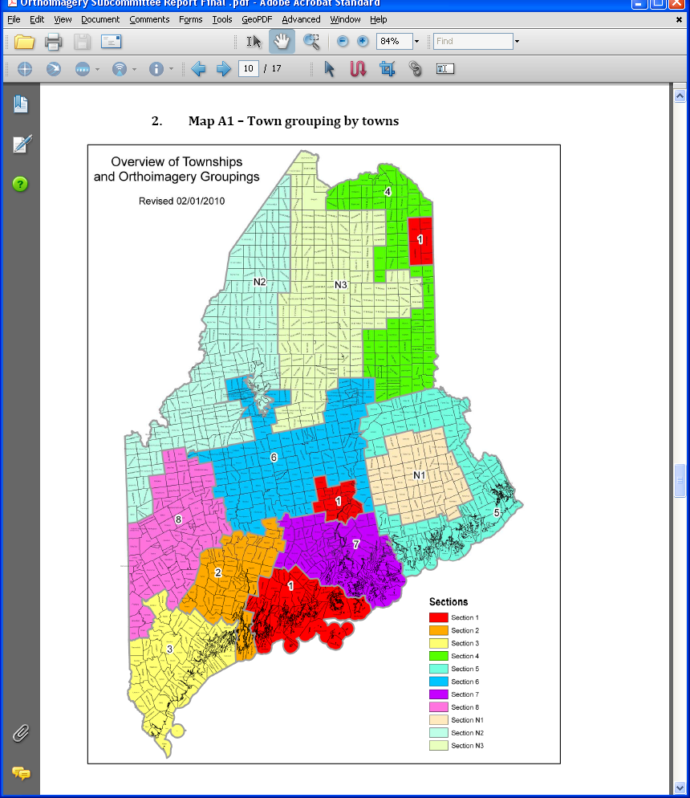

*2010 Collection Plan*

The second was based on a rotation of counties by area.



The chart above shows that we can provide a 5-year coverage for imagery of the whole state if the imagery can be purchased for ~$50.00 per sq/mi. The average yearly cost for this collection plan is ~$312,000.

The intention here is to capture a 12-inch pixel for the state.  
And then if higher resolution is needed in specific areas, that's what we must have a buy up program or some other augmentation of funding.

This this is really intended only to provide a base layer of 12-inch imagery for the whole state rotating every five years.

Other options for funding projects:

1. Provide grants or subgrants to data custodians.
2. Produce pilot projects for things like parcels.
3. Fund GIS activities in underserved areas.
4. Fund research or educational outreach.

These are all things taken from the Charter.

We could reach out and try to find an imagery archive somewhere.  
There are some satellite archives available out there.  
They range from 15 to $45.00, a square mile, depending on whether it's archived data or newly tasked data.

Next year managing the funds won't be as cumbersome.  
There will be a lot of collection earlier in the year and then it will span fiscal years and we'll have to break up some of the money.  
We'll plan how we use that money.  
If we use a 5-year rotation at ~ $300,000 a year we have 200,000 a year leftover to spend on something else.  
  
That'll be a a policy decision that will be made in terms of content priorities.  
  
If we want to come along and do $400,000 of LiDAR, then we have to figure out how to spend that across multiple years in order to get it done too.  
  
Fortunately the aerial imagery capture business has not had too much price pressure from inflation overall. The “airplane” collected prices are up, mostly due to operating costs, but overall, the price pressures are going down. Since satellite imagery became viable the aerial industry has been working harder to make it competitive.

It's possible there could be upward pressure, but it would be surprising if the prices go up much, if at all.

Our LIDAR has been at the same rate for 7 years.  
  
The logical next step is we break up the state into regions and then we'll have to figure out how do we pay for them. The program in the past come out of multiple fiscal years, which we applied in the spring.  
Once we figure out define the program and the regions, then we can work with our financial flows to figure out how do we break up that money, if the board determines that the ortho is a long-term content priority.

It's a significant commitment with the legislative funding between the LIDAR, which makes the DEM and the imagery which it together, then we have a good base map for any other derivative products that that's that state agencies are users are making.  
That gives us some control over the circular error.

Along with the two positions that we got through the legislature and plus the $500,000 for the GeoLibrary for acquisition, there was also another $500,000 for state agency priorities of data acquisition.  
We're trying to work on a program of how to prioritize state agency initiatives, which may often support the Board’s efforts.  
Defining the program is the important thing.

Maria added “I just wanted to say that I know from a public safety perspective that these areas of unorganized territories that have never been flown are a big priority. And those counties that haven't done it, they can't afford it. I would encourage that as an initiative.”

Sarah commented, “I don't know how the money has to move, but is there any way thatwe make it so that we will do all the counties but require some buy in from all the counties?  
That would be less than it is now, so they all paying in.  
Maybe it could be more affordable in some of those more disadvantaged counties so that it isn't just we're charging this county and we're not charging that county.  
We have more money, but, but yeah, I'd rather that we not spend all of it in one place.  
I'd like it to go as far as we can. I don't know if there are ways to do that that so that everybody sharing the burden for the whole state is all those rural places are really important from an environmental perspective too. I'd like to see it all get done, and I'd like everybody to have a little skin in the game too.”

At this point in the meeting the topic changed to Parcels

The general understanding of the overall State-wide program is that about 2/3 of the towns have some kind of parcel data. Some of it is in in GIS formats, some is not.

Not all data that is available on-line is current or up to date.

Jon Giles, Arron Weston, and Greg Copeland did a lot of work on these standards in the past, and the Board has no clear way of enforcing them in a voluntary program.  
Some kind of regional program is needed.

Maria suggested that when they did the 911 addressing, they worked with Councils of Government (COGs) and that worked well.

The point was made that the provision of aerial photography is essential to the parcel efforts, so the ortho program and any parcel program may be related by the provision of the imagery and the acceptance of usage terms by municipalities. There are several areas that need standardizing on a state-wide level and unless that can be enforced the program will continue to be ineffective.

A general discussion of Parcel issues took place including definitions of items, specifics around correct digitization of parcel records, and “parcels-of-record” including multi-structural inclusion.

Do we want to organize a real true rotational imagery program for the State?

There may be alternatives to how we do that because you can parse it different ways, but the question is, “is that something we start to do regularly”?

A discussion was held on the latest Parcel standards document developed by the Board’s previous parcel work group.

Questions Raised?  
Are those standards still good?  
Do we need to update them?

It was generally agreed that the Parcel program should begin with an updated standard that assures the State that any submissions to the program are consistent and uniform.

Maria commented that we could consider brining in a consultant to speed up the update, and even if we did that, we might not be ready by July.

And in any case, we should convene a parcel committee and get them talking about the best thing we can provide.

Maria Jacques made a motion to fully fund the LiDAR grant this year.

Mal Carey seconded the motion.  
Discussion:

What QL level?

Last year, the USGS upgraded the LiDAR collection on their own.

The grant that we applied for specified QL 2 and requested the upgrade again this year.

We think they may do that again due to requirements for the dependent 3DHP products they are building.

With that said we have not seen the contract yet so have no firm information on this.

Yes = 9, No = 0, Abstain = 0 (Anderson, Valentine and Cunningham did not participate)

The motion was passed to recommend payment in full for the LiDAR grant.

Jay asked Nate for clarification on the funding available for the GeoLibrary from the DOT.

Nate explained that it is purposely written for remote sensing, and it doesn't specify whether it's through imagery or LIDAR, but essentially, it's new data development.

It is calendar year funding.

Nate discussed DOT’s prefrences for imagery capture by saying that like Maria was saying, getting those areas that where the local governments are not going to get it themselves are more likely a target for DOT. Especially those rural areas where there is infrastructure there, and the local towns are not going to run out and grab aerials for whatever reasons.

A general discussion of aerial imagery collection ensued.

1. Remote typically underserved areas are a priority.
2. When we make a plan for collection it should be publicized and outreach made to all areas to facilitate buy-in and minimize confusion about the program.
3. A multi-year budget is needed to execute the program.
4. Public safety is a big need for imagery, some areas are over 25 years old.
5. Taxation and real property management are equally important.
6. There is an order to these collections:
   1. LiDAR (for DEM)
   2. Orthoimagery (produced using DEM)
   3. Parcels and other imagery derived products.

Any program we establish should consider all these elements.

2:00 Actions from Planning Session

1. Leticia asked for volunteers for 2 working groups.
   1. Remote Sensing
   2. Parcels
2. Greg agreed to work on Parcels, as did Aaron, Greg will attempt to recruit Jon Giles.
3. Nate agreed to work on remote sensing as did Mal. Clarence will provide MeGIS support.
4. Jay will participate in both groups and provide administrative support.

New Business

Leticia asked if there was any new business. There was none.

Adjourn

Having no further new business, the meeting was adjourned at 1:55 PM